Procedure to build VxWorks OS libraries and OpenSSL 1.0.1s

The following CDs are to be installed in the below order. The components to be installed are to be the same as that given under each CDs. Host system is Windows XP version 5.1 Service Pack 3.
[Note: Initial setup was using install products keys from WRKK, which did not enable kernel source for MIPS component and failed to build OS libraries. This was rectified after installing with customer(Iwatsu)’s install keys.]

Step 1:

Install CDR-R110214.1-1

Wind River Workbench 2.4
100-R110787 | Wind River Workbench 2.4
100-R110790 | Wind River Workbench Debugger
100-R110793 | Debugger Support for VxWorks Target OS
100-R110799 | Debugger Support for Linux Desktop
100-R110815 | Wind River Target Server Connection Processor Support | Architecture:PPC
100-R110821 | Wind River Target Server Connection Processor Support | Architecture:MIPS
100-R110830 | Wind River Target Server Connection Processor Support | Architecture:SH
100-R110833 | Wind River OCD Connection Processor Support | Architecture:PPC
100-R110836 | Wind River OCD Connection Processor Support | Architecture:MIPS
100-R110851 | Wind River System Viewer for VxWorks

Step 2:

Install CDR-R110232.1-1

Wind River Compiler 5.3
100-R111199 | Wind River Compiler
100-R111215 | Wind River Compiler for VxWorks 6.x | Architecture:MIPS
100-R111216 | Wind River Compiler for VxWorks 6.x | Architecture:PPC
100-R111217 | Wind River Compiler for VxWorks 6.x | Architecture:SH

Step 3:

Install CDR-R110233.1-1

Wind River GNU Compiler 3.3.2 for VxWorks 6.2

100-R111009 | Wind River GNU Compiler for VxWorks | Architecture:PPC
100-R111015 | Wind River GNU Compiler for VxWorks | Architecture:MIPS
100-R111021 | Wind River GNU Compiler for VxWorks | Architecture:SH

Step 4:

Install CDR-R110234.1-1

VxWorks 6.2 and General Purpose Technologies
100-R111241 | VxWorks | Architecture:PPC
100-R111243 | VxWorks | Architecture:MIPS
100-R111244 | VxWorks | Architecture:SH
100-R111248 | VxMP | Architecture:PPC
100-R111250 | VxMP | Architecture:MIPS
100-R111251 | VxMP | Architecture:SH
100-R111255 | VxWorks Processor Adapter | Architecture:PPC x | ProcessorFamily:PPC40X
100-R111256 | VxWorks Processor Adapter | Architecture:PPC x | ProcessorFamily:PPC44X
100-R111257 | VxWorks Processor Adapter | Architecture:PPC x | ProcessorFamily:PPC6XX
100-R111258 | VxWorks Processor Adapter | Architecture:PPC x | ProcessorFamily:PPC7XX
100-R111259 | VxWorks Processor Adapter | Architecture:PPC x | ProcessorFamily:PPC97X
100-R111260 | VxWorks Processor Adapter | Architecture:PPC x | ProcessorFamily:MPC8XX
100-R111261 | VxWorks Processor Adapter | Architecture:PPC x | ProcessorFamily:MPC52XX
100-R111262 | VxWorks Processor Adapter | Architecture:PPC x | ProcessorFamily:MPC74XX
100-R111263 | VxWorks Processor Adapter | Architecture:PPC x | ProcessorFamily:MPC82XX
100-R111264 | VxWorks Processor Adapter | Architecture:PPC x | ProcessorFamily:MPC83XX
100-R111265 | VxWorks Processor Adapter | Architecture:PPC x | ProcessorFamily:MPC85XX
100-R111272 | VxWorks Processor Adapter | Architecture:MIPS x | ProcessorFamily:BCM12XX
100-R111274 | VxWorks Processor Adapter | Architecture:MIPS x | ProcessorFamily:MTI4KX
100-R111275 | VxWorks Processor Adapter | Architecture:MIPS x | ProcessorFamily:MTI5KX
100-R111276 | VxWorks Processor Adapter | Architecture:MIPS x | ProcessorFamily:MTI24KX
100-R111279 | VxWorks Processor Adapter | Architecture:MIPS x | ProcessorFamily:RM9XXX
100-R111281 | VxWorks Processor Adapter | Architecture:MIPS x | ProcessorFamily:VR55XX
100-R111282 | VxWorks Processor Adapter | Architecture:MIPS x | ProcessorFamily:TX49XX
100-R111283 | VxWorks Processor Adapter | Architecture:SH x | ProcessorFamily:SH4
100-R111291 | VxWorks Device Drivers | Architecture:PPC
100-R111293 | VxWorks Device Drivers | Architecture:MIPS
100-R111294 | VxWorks Device Drivers | Architecture:SH
100-R111298 | Wind River USB 2.2.2 | Architecture: PPC
100-R111300 | Wind River USB 2.2.2 | Architecture: MIPS
100-R111301 | Wind River USB 2.2.2 | Architecture: SH
100-R111312 | Wind River PPP 2.2.1 | Architecture: PPC
100-R111314 | Wind River PPP 2.2.1 | Architecture: MIPS
100-R111315 | Wind River PPP 2.2.1 | Architecture: SH
100-R111319 | Wind River TIPC 1.2 | Architecture:PPC
100-R111321 | Wind River TIPC 1.2 | Architecture:MIPS
100-R111322 | Wind River TIPC 1.2 | Architecture:SH
100-R111326 | Wind River VxWorks Simulator | Host:Windows
100-R111329 | VxWorks Utilities | Host:Windows
100-R111332 | VxWorks OS Source
100-R111333 | VxWorks Kernel Source | Architecture:PPC
100-R111336 | VxWorks Kernel Source | Architecture:SH
100-R111340 | VxMP Source
100-R111341 | Wind River USB 2.2.2 Source
100-R111342 | Wind River Network Stack 3.0 Source
100-R111373 | Wind River Network Stack 3.0 Platform Edition Source
100-R111344 | Wind River PPP 2.2.1 Source
100-R111345 | Wind River TIPC 1.2 Source
100-R111346 | Wind River VxWorks Simulator Source | Host:Windows

Step 5:

Install CDR-R110236.1-1

VxWorks 6.2 BSPs for MIPS
100-R111236 | VxWorks Reference BSPs | Architecture:MIPS

Step 6:

Install CDR-R110238.1-1

VxWorks 6.2 BSPs for PowerPC
100-R111238 | VxWorks Reference BSPs | Architecture:PPC

Step 7:

Install CDR-R110513.1-1

Wind River Platform Technologies VxWorks Edition 3.2
100-R110985 | Wind River Platform CD Common Source
100-R110988 | Wind River CAN 1.5.1 Source
100-R110989 | Wind River CLI | Web | MIBway 4.4.2 Source
100-R110990 | Web | MIBway Tools 4.4: Windows
100-R110991 | Wind River DCOM 2.3.2 | Source: Windows
100-R110992 | Wind River Firewall 2.1 Source
100-R110993 | Wind River IPsec and IKE 3.2 Source
100-R110994 | Wind River Learning Bridge 1.3.1 Source
100-R110995 | Wind River Media Library 4.1 Source
100-R110996 | Wind River NAT 2.1 Source
100-R110997 | Wind River OPC 3.1.1 Source: Windows
100-R110998 | Wind River OSPF 3.1.1 Source
100-R110999 | Wind River RADIUS Client 1.3 Source
100-R111000 | Wind River Security Libraries 1.1 Source
100-R111001 | Wind River SNMP 10.0.2 Source
100-R111002 | Wind River SNMP Tools 10.0: Windows
100-R111005 | Wind River SSL 1.1 Source
100-R111006 | Wind River Web Services 1.3 Source
100-R111007 | Wind River Wireless Ethernet Driver 2.2 Source
100-R111008 | Wind River Wireless Security 2.1 Source

Step 8:

Install CDR-R110251.1-1

Wind River ScopeTools 5.4
100-R110763 | Wind River StethoScope 7.8 for VxWorks 6.x
100-R110766 | Wind River MemScope 3.6 for VxWorks 6.x
100-R110769 | Wind River ProfileScope 4.8 for VxWorks 6.x

Step 9:

Install CDR-R110214.1-2

Wind River Workbench 2.4 Service Pack 1
100-R110787 | Patch for Wind River Workbench 2.4
100-R110790 | Patch for Wind River Workbench Debugger
100-R110793 | Patch for Debugger Support for VxWorks Target OS
100-R110799 | Patch for Debugger Support for Linux Desktop
100-R110815 | Patch for Wind River Target Server Connection Processor Support | Architecture:PPC
100-R110821 | Patch for Wind River Target Server Connection Processor Support | Architecture:MIPS
100-R110830 | Patch for Wind River Target Server Connection Processor Support | Architecture:SH
100-R110833 | Patch for Wind River OCD Connection Processor Support | Architecture:PPC
100-R110836 | Patch for Wind River OCD Connection Processor Support | Architecture:MIPS

STEP 10:

Install CDR-R110234.1-2

VxWorks 6.2 and General Purpose Technologies Service Pack 1
100-R111241 | Patch for VxWorks | Architecture:PPC
100-R111243 | Patch for VxWorks | Architecture:MIPS
100-R111244 | Patch for VxWorks | Architecture:SH
100-R111272 | Patch for VxWorks Processor Adapter | Architecture:MIPS x | ProcessorFamily:BCM12XX
100-R111274 | Patch for VxWorks Processor Adapter | Architecture:MIPS x | ProcessorFamily:MTI4KX
100-R111275 | Patch for VxWorks Processor Adapter | Architecture:MIPS x | ProcessorFamily:MTI5KX
100-R111276 | Patch for VxWorks Processor Adapter | Architecture:MIPS x | ProcessorFamily:MTI24KX
100-R111279 | Patch for VxWorks Processor Adapter | Architecture:MIPS x | ProcessorFamily:RM9XXX
100-R111281 | Patch for VxWorks Processor Adapter | Architecture:MIPS x | ProcessorFamily:VR55XX
100-R111282 | Patch for VxWorks Processor Adapter | Architecture:MIPS x | ProcessorFamily:TX49XX
100-R111291 | Patch for VxWorks Device Drivers | Architecture:PPC
100-R111293 | Patch for VxWorks Device Drivers | Architecture:MIPS
100-R111294 | Patch for VxWorks Device Drivers | Architecture:SH
100-R111298 | Patch for Wind River USB 2.2.2 | Architecture: PPC
100-R111300 | Patch for Wind River USB 2.2.2 | Architecture: MIPS
100-R111301 | Patch for Wind River USB 2.2.2 | Architecture: SH
100-R111319 | Patch for Wind River TIPC 1.2 | Architecture:PPC
100-R111321 | Patch for Wind River TIPC 1.2 | Architecture:MIPS
100-R111322 | Patch for Wind River TIPC 1.2 | Architecture:SH
100-R111326 | Patch for Wind River VxWorks Simulator | Host:Windows
100-R111329 | Patch for VxWorks Utilities | Host:Windows
100-R111332 | Patch for VxWorks OS Source
100-R111341 | Patch for Wind River USB 2.2.2 Source
100-R111342 | Patch for Wind River Network Stack 3.0 Source
100-R111346 | Patch for Wind River VxWorks Simulator Source | Host:Windows

Step 11:

Install CDR-R110236.1-2

VxWorks 6.2 BSPs for MIPS Service Pack 1
100-R111236 | Patch for VxWorks Reference BSPs | Architecture:MIPS

Step 12:

Install CDR-R110513.1-3

Wind River Platform Technologies VxWorks Edition 3.2 Service Pack 2
100-R110989 | Patch - Wind River CLI, Web | MIBway 4.4.3 Source
100-R110993 | Patch - Wind River IPsec and IKE 3.2.2 Source
100-R111000 | Patch - Wind River Security Libraries 1.1.1 Source

Step 13:

Install CDR-R118135.1-1

VxWorks 6.2.1 Patch 00037220

VxWorks 6.2.1 Patch 00037220

Step 14:

Install CDR-R139703.1-1

VxWorks 6.2 Point Patch WIND00030127

VxWorks 6.2 Patch WIND00030127

Step 15:

Install CDR-R138426.1-1

VxWorks 6.2 Cummulative FS Patch 2

VxWorks 6.2 Cummulative FS Patch 2

Step 16:

InstallCDR-R140328.1-1

VxWorks 6.2 Point Patch WIND00110867

VxWorks 6.2 Patch WIND00110867

Step 17:

Install CDR-R122272.1-1

VxWorks 6.2 Point Patch WIND00062451

VxWorks 6.2 Patch WIND00062451

Installing IWE14057 patch and build Instructions

Step 18:

On DEV PC:
- Unzip JPN-IWE14057-5705_rel.zip to a temporary directory. (e.g. c:\iwe14057\)
- Overwrite following directories
<WorkbenchInstallationDirectory>\VxWorks-6.2\target
withtarget folder from unzipped directory.
Example : C:\iwe14057\JPN-IWE14057-5705_rel\src\target

Step 19:
Modify following files as described below
File Location
<WorkbenchInstallationDirectory>\VxWorks-6.2\target\src\Makefile
Changes required:
-> Search for "COMMON_SUBDIRS" (where you will see wind,wrn,wvlisted)
-> Append "security" and "ssl" to the list of COMMON_SUBDIRS as shown in below fig.

Step 20:
File Location
<WorkbenchInstallationDirectory>\VxWorks-6.2\target\config\all\usrConfig.c

Changes required:
-> define INCLUDE_USER_APPL macro by adding below line
#define INCLUDE_USER_APPL
->In the INCLUDE_USER_APPL block add below two lines to call those functions as shown in below fig.
secLibInit();
sslInit();

Step 21:
File Location
<WorkbenchInstallationDirectory>\VxWorks-6.2\target\src\drv\wlan\management\Makefile
Changes required:
- search for "IS_DOT11SNMP" and comment that line as shown in below fig.

Step 22:
File Location
<WorkbenchInstallationDirectory>\VxWorks-6.2\target\src\ppp\management\snmpAgent\Makefile
Changes required:
- search for "IS_SNMP_INSTALLED" and comment that line as shown in below fig.

Step 23: IWE216532-TLS bug-fixes and task lock release
Procedure to apply code changes:
Note : Assume that secLibInit() function is used to initialize WRsecurity library as part of OS startup.(typically,usrRoot() in~\target\config\all\usrConfig.c)]
Replace following files in the environment by corresponding current fix files
~\target\src\security\compatibility\vxworks\sslMemoryRoutines.c
~\target\src\security\compatibility\rsa\rsa_cci.c
~\target\config\comps\src\usrCertsInit.c

Step 24:
- Build VxWorks-6.2 for specific CPU( for ex: PPC32,MIPS64) by following below steps:

- Open VxWorksDevlopmentShell(start->all programs->windriver->vxworks-6.2->vxworks development shell).
- Goto directory <WorkbenchInstallationDirectory>\VxWorks-6.2\target\src
- Build using 'make' command as make CPU=<cpu name> TOOL=diab

e.g :makeCPU=MIPS64 TOOL=diab

Step 25:
1.Create Image Project Under WindRiver Workbench
- Open Workbench GUI(start->All programs->windriver->workbench 2.4).
- Create new VxWorksimage project from Workbench-2.4 menu(file->new->vxworks image project).
- Give project name and click on 'next' .
- Select BSP(Board Supporting Package) and tool chain and click on 'finish'. Goto kernel configuration of the project from project window.
- In component tree, enable vxWorkscomponentsINCLUDE_SSL and INCLUDE_SSL_APPS by including network security components under network components as shown in below fig.
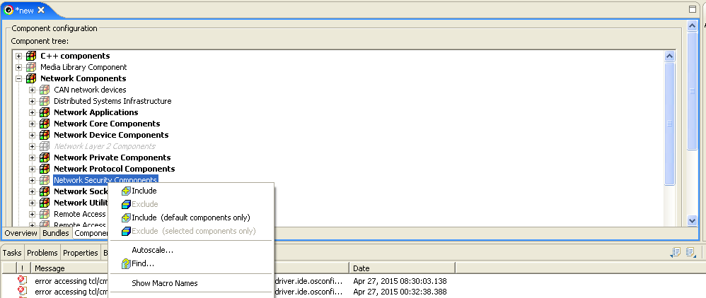

- Include Kernel shell ComponentsunderDevelopment Tools Components(select all)

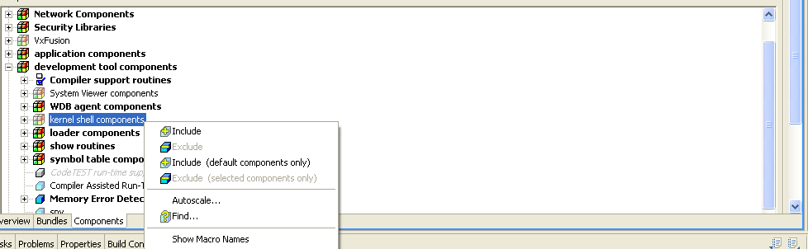

- Exclude “GNU compiler support routines” in “compiler support routines”
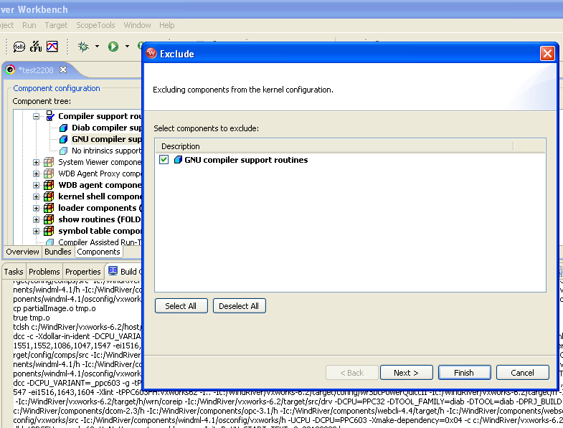

- Build/Rebuild Project.

- By default VxWorks image will be present in following directory.<WindRiverInstalledDirectory>\workspace\project_name\default\VxWorks
Steps To Build For Tasklock:
Test code is included under Testcode directory in attachment..
To use test code,
BSP directory:
Modify config.h in bsp directory (~\target\config\<bspdirname>\config.h) to define following macro.
#define USER_APPL_INIT \
{ \
IMPORT int wrkkssltest (); \
taskSpawn ("tWrkkssltest", 30, 0, 3000, wrkkssltest, 0, 0, 0,0,0,0,0,0,0,0); \
}
(Make sure INCLUDE_USER_APPL is defined and USER_APPL_INIT is invoked from usrRoot() in ~\target\config\all\usrConfig.c)
Add following files from attachment to BSP directory and edit BSP Makefile to add them to MACH_EXTRA
wrkkssltest.c
wrSSLTest.c
Execute step No:24

/EOD

